Joint Optimal Service Chain Allocation, VNF instantiation and Metro Network Resource Management Demonstration

F.J. Moreno-Muro¹, C. San-Nicolas-Martinez¹, E. Martin-Seoane¹, M. Garrich¹ ², P. Pavon-Marino¹, O. Gonzalez³ V. Lopez³
¹Universidad Politécnica de Cartagena, Cuartel de Antiguones, Plaza del Hospital 1, 30202 Cartagena, Spain
²CPqD Foundation, Parque II do Polo de Alta Tecnologia, Campinas, São Paulo, Brazil
³Telefonica GCTO, Ronda de la Comunicación, Madrid, Spain
Email: javier.moreno@upct.es

Abstract: In a metro network with VIMs orchestrated by an ETSI-OSM instance, and an optical transport controller, we demonstrate optimized service chain provisioning using the open-source Net2Plan tool with interfaces to OSM (new) and transport controller.
OCIS codes: (060.4250) Networks; (060.4256) Network Optimization.

1. Introduction
Metropolitan area networks play an essential role in telecom operators’ infrastructure to satisfy the near-future requirements of the 5G era. Among other key performance indicators, 5G networks are expected (i) to use a scalable management framework enabling fast deployment of novel applications, (ii) to reduce the network management OPEX by at least 20% compared to today and (iii) to ensure End-to-End latency below 1 ms. Software-defined networking (SDN) network function virtualization (NFV) are key technologies to address (i) because they enable dynamic management of virtual network functions (VNFs) across an advanced programmable network. Moreover, (ii) can be met instantiating VNFs in standard commodity hardware and exploiting hardware disaggregation and multi-vendor interoperability with SDN. Finally, optimization is imperative to guarantee (iii) by fully exploiting the network resources and allocating service chains (SCs) of multiple VNFs in the most efficient manner.
In this context, the Metro-Haul project [1] proposes cost-effective, energy-efficient, agile and programmable metro networks that are scalable for 5G access and future requirements, designing metro nodes, which interface effectively with both 5G access and multi-Tbit/s elastic core networks. In a Metro-Haul network, Access Metro Edge Nodes (AMENs) and Metro Core Edge Nodes (MCENs) are interconnected through dynamic optical bandwidth allocation and equipped with full compute and storage resources and networking (transmission and switching) capabilities. MCENs are dimensioned with more IT resources than AMENs due to its proximity to the core network.
2. Overview
This demonstration proofs the use of the specialized open-source planning tool Net2Plan [2] to assist the NFV-Orchestrator (NFV-O) Open-Source MANO (OSM) [3] in the optimal VNF instantiation, SC allocation and optimization of transport network. An overview of the demonstration is shown in Fig. 1, which is composed of the following control (IT and network) modules:
- Operations Support System (OSS). Represents an operator that deploys an application service. A user can request SC-based demands through a GUI programmed in Net2Plan to emulate operator’s behavior.
- NFV-O. Is represented by OSM which is in charge of the virtualization infrastructure that manages and deploys VNFs leveraging in VIMs so that IT resources are taken into account.
- Netphony, is a BGP-LS Speaker, a Traffic Engineering Database and a Topology Module which emulates the transport network, it contains the T-SDN controller.
- SCCE: a Service Chain Computation Element (SCCE) is an evolution of the well-known Path Computation Element (PCE) tuned for handling not only regular path allocations, but also service chain allocations, where the path is constrained to traverse a sequence of VNFs. For this, SCCE has visibility of both IT and network resources occupation. The SCCE is implemented leveraging on other instance of Net2Plan planning tool, to take benefit of the new service chains allocation algorithms developed over it.
The proof of concept also demonstrates the use of the following open interfaces:
- Management Interfaces: (i) OSS-SCCE, is a bidirectional communication between the OSS and SCCE modules. We will investigate two options for implementing this interface, a) an extension of PCEP protocol (e.g. reusing some of the concepts in RFC 2119 adapted to SDN/NFV context), or ii) a RestAPI based on YANG model definitions. (b)
- OSS-T-SDN, a regular SDN North Bound Interface is used by the operator to notify Netphony about the changes to apply in the emulated transport network. (iii)
- OSS-NVF-O, the OSM RestAPI allows OSS to instruct NFV-O to apply changes in the IT resources and the VNF deployments.
- Monitoring Interfaces: (i) NFV-O-SCCE, SCCE is aware of NFVI and IT resources via the RestAPI provided by OSM and (ii) T-SDN-SCCE, Netphony provides network visibility to SCCE through the BGP-LS protocol.
The service chain allocation workflow is: (i) A user introduces the SC request through the Net2Plan GUI, providing: the origin and end nodes within the emulator network, the sequence of VFs to traverse and the demand size in Gbps. (ii) The request arrives to the SCCE that has the complete knowledge of the IT, VNF and network resources, VNF catalogue. The SCCE runs a specialized algorithm for SC allocation, that may involve new VNFs instantiation, and it sends the results to the OSS. (iii) The OSS instructs NFV-O where and how to use the available IT resources and the VNFs to traverse, and instructs Netphony (XXXX interface) for the flow allocations in the metro.

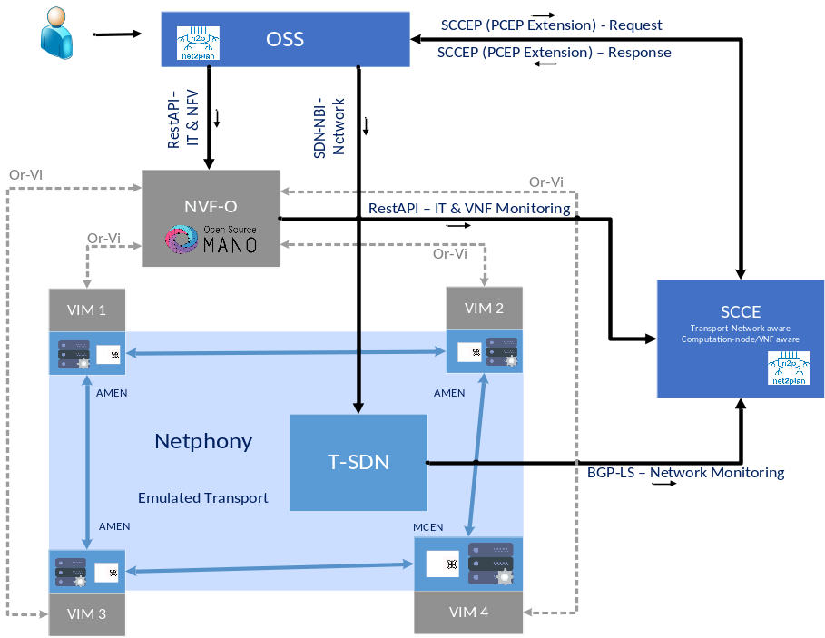
Fig. 1. Demonstration overview. NFV-O: Network Function Virtualization - Orchestrator. OSS: operational support systems VIM: Virtual infrastructure manager. Netphony: BGP-LS Speaker and Traffic Engineering Database
3. Innovation
SND/NFV networks imply unprecedented dynamicity, which means unprecedented challenges for network optimization, e.g. the optimization of the service chain and network services allocations. This demo is a proof of concept where a new module (called SCCE) is in charge of service chain allocations in an optical metro network, considering both IT and network resources, providing an OaaS (Optimization as a Service) functionality, an aspect not commonly considered in other demos [4][5]. OSM is selected for handling distributed IT resources (controlling one VIM per node), NetPhony is selected for network emulation. The SCCE is based on the open-source planning tool Net2Plan, hosting SC allocation and VNF instantiation algorithms.

4. OFC Relevance
The proposed demonstration is relevant to OFC since it offers a proof-of-concept in a dynamic SDN/NFV environment optimized by a planning tool in order to test some operator’s tasks within the incoming 5G era totally relevant for the extremely challenging forecasted Internet scenario.
Acknowledgments
The research leading to these results has received funding from the European Commission for the H2020-ICT-2016-2 METRO-HAUL project (G.A. 761727). INSPIRING-SNI???.
References
- Metro-Haul Project. https://metro-haul.eu/
- P. Pavon-Marino et al., “Net2Plan: An Open Source Network Planning Tool for Bridging the Gap between Academia and Industry”, IEEE Networks, Sept. 2015.
- Open Source Mano. [Online]. Avalilable: https://osm.etsi.org/
- V.Mehmeri et. al., “Software-Programmed Optical Networking with Integrated NFV Service Provisioning”, OFC 2017, March 2017
- A. Hammad et. al., “Demonstration of NVF Content Delivery using SDN-enabled virtual infrastructures”, OFC 2017, March 2017

